To: Sean Good

From: Christopher Walker

CC: Melinda Latona

Audit Number: 31142 Audit Date: 08/31/2022

Project Name: My HealtheVet

Project Status: **Non-Conformant**

Product Type: Web Application

# Section 508 Audit Report

## Revision History

|  |  |  |
| --- | --- | --- |
| **Date** | **Version** | **Description** |
| 08/31/2022 | 1.0 | Initial Audit |

## Audit Methodology:

This is a Sampling Audit Report, not an end-to-end test which can result in items not being reported in this audit. It is the onus of the VA project team to run a complete end-to-end test to ensure 508 compliance.

This conformance audit is a manual review of screens checking the content against the WCAG 2.0 A and AA standards and 508 Law requirements.

For ease of recognition and tracking, Section 508 defects, found during the audit, are listed in a “Defect Matrix” in the Audit Results section of this report. The total number of defects are provided, organized by severity, in a “Severity Matrix.”

This document is a technical document written primarily for the application developer(s) and 508 testers and as such is intended to assist in the remediation of any Section 508 defects encountered.

### **Auditing Environment:**

|  |  |  |
| --- | --- | --- |
| Tool Type | Name | URL |
| Operating System | Windows 10 | <https://www.microsoft.com> |
| Screen Reader | JAWS 2022 | <https://www.freedomscientific.com> |
| Screen Reader | NVDA 2021.3.3 | <https://www.nvaccess.org> |
| Screen Magnifier | ZoomText 2022 | <https://www.zoomtext.com> |
| Voice Recognition | Dragon NaturallySpeaking 15 | <https://www.nuance.com> |
| Browser | Microsoft Edge 100 | <https://www.microsoft.com> |
| Browser | Chrome Version 101 | <https://www.google.com> |
| Color Contrast | Colour Contrast Analyser 1.0 | <https://www.paciellogroup.com> |
| PDF Reader | Adobe Acrobat DC | <http://www.adobe.com> |
| PDF Plugin/Checker | CommonLook PDF | <https://www.commonlook.com> |

## References/Links for Developers:

For a Quick Reference Guide on Section 508 Documents and other related resources please refer to the following links:

<http://www.section508.gov>

<http://www.access-board.gov/>

<http://webaim.org>

<https://www.w3.org/WAI/WCAG21/quickref/>

## Defect Matrix

|  |  |  |  |  |  |  |  |  |
| --- | --- | --- | --- | --- | --- | --- | --- | --- |
| Defect Number | Date Audited | Software  Version Audited | Defect Description | Defect Criterion | Defect Severity | Recommended Resolution | Defect Status | Comments |
|  | 08/31/2022 | 08/31/2022 | Non-text content does not have a text equivalent. | 1.1.1 Non-text Content | Critical | Make sure that non-text content has a text equivalent. | New | See Note 1 for examples |
|  | 08/31/2022 | 08/31/2022 | Information, structure, and relationships conveyed through presentation cannot be understood (programmatically determined). | 1.3.1 Info and Relationships | Critical | Make sure that information, structure, and relationships conveyed through presentation can be understood (programmatically determined). | New | See Note 2 for examples |
|  | 08/31/2022 | 08/31/2022 | Text or images of text have a contrast ratio less than 4.5:1. | 1.4.3 Contrast (Minimum) | Medium | Make sure that the color contrast ratio for text or images of text is at least 4.5:1. | New | See Note 3 for examples |
|  | 08/31/2022 | 08/31/2022 | Images of text are used where text could convey the same information. | 1.4.5 Images of Text | Critical | Make sure that images of text are not used where text could convey the same information. | New | See Note 4 for examples |
|  | 08/31/2022 | 08/31/2022 | The purpose of links cannot be determined from link text alone or from context. | 2.4.4 Link Purpose (In Context) | High | Make sure that the purpose of each link can be determined from the link text alone or from context. | New | See Note 5 for examples |
|  | 08/31/2022 | 08/31/2022 | Headings and labels do not describe the topics or purpose of the content to which they belong. | 2.4.6 Headings and Labels | Medium | Make sure that headings and labels describe the topics or purpose of the content to which they belong. | New | See Note 6 for examples |
|  | 08/31/2022 | 08/31/2022 | Keyboard operable user interface elements do not have a visible indication of focus. | 2.4.7 Focus Visible | Critical | Make sure keyboard operable interface elements have a visible indication of focus. | New | See Note 7 for examples |
|  | 08/31/2022 | 08/31/2022 | Labels and instructions are not provided when content requires user input. | 3.3.2 Labels or Instructions | Critical | Make sure that labels and instructions are provided when content requires user input. | New | See Note 8 for examples |
|  | 08/31/2022 | 08/31/2022 | Content is not properly encoded and causes assistive technology to convey incorrect information. | 4.1.1 Parsing | High | Make sure that content is properly encoded and can convey correct information to assistive technology. | New | See Note 9 for examples |
|  | 08/31/2022 | 08/31/2022 | The name, role, state or value of user interface elements in the product cannot be understood (programmatically determined). | 4.1.2 Name, Role Value | Critical | Make sure that the name, role, state or value of user interface elements in the product can be understood (programmatically determined). | New | See Note 10 for examples |
|  | 08/31/2022 | 08/31/2022 | A visual mode that enables users to make use of limited vision is not provided. | 302.2 With Limited Vision | Critical | Make sure that a visual mode that enables users to make use of limited vision is provided. | New | See Note 11 for examples |

### Severity Matrix

|  |  |
| --- | --- |
| Severity | Number |
| Critical | 7 |
| High | 2 |
| Medium | 2 |
| Low | 0 |
| **Total** | 11 |

#### Notes:

The following examples are not and should not be interpreted as an exhaustive or complete list of all instances of a given accessibility defect. Examples were chosen to ease reproduction of the accessibility defect and to illustrate where multiple defects produce additional barriers to accessibility in combination. Stakeholders of the product should conduct internal testing to identify any additional instances of defects identified in this report. However, because these examples list the end-user experience of accessibility, defects identified may result from or be explained in terms of multiple criteria.

At the direction of the product’s stakeholder, the Audit of 08/31/2022 was conducted on product version V4.1 at [https://www.myhealth.va.gov/mhv-portal-web/home](https://gcc02.safelinks.protection.outlook.com/?url=https%3A%2F%2Fwww.myhealth.va.gov%2Fmhv-portal-web%2Fhome&data=05%7C01%7C%7C5ddc3f24759f4440dbbe08da80523db4%7Ce95f1b23abaf45ee821db7ab251ab3bf%7C0%7C0%7C637963387947015860%7CUnknown%7CTWFpbGZsb3d8eyJWIjoiMC4wLjAwMDAiLCJQIjoiV2luMzIiLCJBTiI6Ik1haWwiLCJXVCI6Mn0%3D%7C3000%7C%7C%7C&sdata=Uo%2FRchfIfhizNK7IWCcLXJIhEiBRMcth%2B3%2BJNSNPpII%3D&reserved=0) in Google Chrome.

##### Note 1, Defect 1:

Non-text content does not have a text equivalent. The following are examples:

* Example 1. Graphics have text equivalents that do not describe the purpose, information, or data of the graphic. It occurs on My HealtheVet Sign in page under option 3. The user of screen reader hears “VA Logo graphic” instead of “VA Seal U.S. Department of Veterans Affairs Graphic.” (**New:** **08/31/2022**).
* Example 2. It occurs on “ Option 1: Start using the new VA sign in” link page. Work path: My HealtheVet Home page-> Press on Login link-> Press on Option 1: ‘Start using the new VA sign in’ link, i.e., during navigation with tab key on keyboard the user of screen reader hears “Go to VA.gov link graphic” instead of “VA Seal U.S. Department of Veterans Affairs link Graphic.” (**New: 08/31/2022).**
* Example 3. It occurs on Option 3: DS Logon link page. Work path: My HealtheVet Home page-> Press on Login link-> Press on Option 3 DS Logon link. When the user press “G” on keyboard to find out image/graphics alt-text, the screen reader announces, “Return home graphic” instead of “VA Seal U.S. Department of Veterans Affairs Graphic.” See figure below. Check all instances of same issue. (**New: 08/31/2022).**
* Example 4. It occurs on Login page. The when the user press “G” on keyboard to find out image/graphics alt-text, the screen reader announces, “VA Logo graphic” instead of “VA Seal U.S. Department of Veterans Affairs Graphic.” (**New: 08/31/2022).**

##### Note 2, Defect 2:

Information, structure, and relationships conveyed through presentation cannot be understood (programmatically determined). The following are examples:

* Example 1. **“Search edit field” in** this productconveyed through presentation cannot be understood by the user of Assistive Technology. It occurs on My HealtheVet home page, i.e**.,** during navigation with tab key on keyboard for the “Search edit field,” the screen reader user hears “Search button collapsed.” Visually, there is no expand or collapse button available on the Search edit field. When a user press on Search button, the Search button expanded, then the user of screen reader hears, “Search region, Search: edit Combo collapsed. To set the value use the Arrow keys or type the value.” No search option is available. (**New: 08/31/2022**).
* Example 2. Throughout the product the **s**tructure of the Date edit field conveyed through presentation cannot be understood by the user of Assistive Technology. It occurs on Start Date/Stop Date edit fields. Work Path: [My HealtheVet](https://www.myhealth.va.gov/mhv-portal-web/web/myhealthevet) Home-> Select [Pharmacy](https://www.myhealth.va.gov/mhv-portal-web/pharmacy) menu-> Select My Medication List-> Press on Add a medication link:- on Start Date/Stop Date edit field; i.e., during navigation with the tab key on keyboard, the user of screen reader hears “underline underline/underline underline/ underline underline underline underline(_ _/_ _/_ _ _ _)” instead of the date format “MM/DD/YYYY.” Check all instances of same issue. (**New: 08/31/2022**).
* Example 3. Required field symbol ‘*’ is not conveyed through presentation by the Assistive technology. It occurs on Birth date required field. Work Path: [My HealtheVet](https://www.myhealth.va.gov/mhv-portal-web/web/myhealthevet) Home page-> Press on Contact us link-> Press on Forgotten User Id link-> on Birth Date Combo box required field; i.e., during navigation with tab key on keyboard the screen reader announces “Birth Date Combo box” instead of “Birth Date star(*) Combo box.” Check all instances of same issue. (**New: 08/31/2022**).

### Example 4. Throughout the product, table row headers are not specified to the user of Assistive Technology. As the screen reader user navigates the rows and columns of table in this product, the relationship between the row header is not announced. This behavior is present in the [My HealtheVet](https://www.myhealth.va.gov/mhv-portal-web/web/myhealthevet) on My Medication List page. Work Path: [My HealtheVet](https://www.myhealth.va.gov/mhv-portal-web/web/myhealthevet)->Select [Pharmacy](https://www.myhealth.va.gov/mhv-portal-web/pharmacy) menu-> Select My Medication List sub-menu-> on Allergies and Adverse Reactions Summary table. Check all instances of same issue. (New: 08/31/2022).

### Example 5. Throughout the product the ****s****tructure of the Radio button group conveyed through presentation cannot be understood by the user of Assistive Technology. It occurs on “My Profile page” under the text “SUBSCRIBE TO EMAIL NOTIFICATIONS AND REMINDERS” heading level 3. Work path: [My HealtheVet](https://www.myhealth.va.gov/mhv-portal-web/web/myhealthevet)-> Select [Personal Information](https://www.myhealth.va.gov/mhv-portal-web/personal-information) menu-> Select My Profile sub-menu; i.e., during navigation with the tab key on keyboard, the user of screen reader hears “one of one radio button” instead of “one of two radio button” to change selection use up and down arrow. Check all instances of same issue. (New: 08/31/2022).

##### Note 3, Defect 3:

##### Text or images of text have a contrast ratio less than 4.5:1. The following are examples:

* Example 1. The text “Health.” has a contrast ratio of 3.7:1 (#6288A8 and #FFFFFF). This behavior is present in VA Mobile Apps. Work Path: [My HealtheVet](https://www.myhealth.va.gov/mhv-portal-web/web/myhealthevet)-> Select [MHV Community](https://www.myhealth.va.gov/mhv-portal-web/mhv-community) menu->VA Mobile Apps. See figure 1 below. (**New: 08/31/2022).**

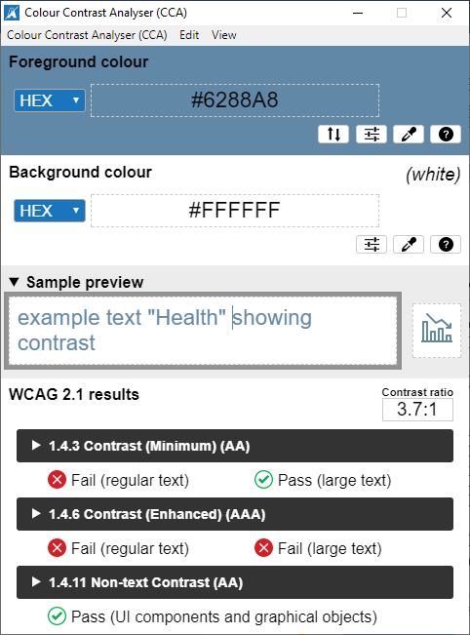

Figure

* Example 2. The text “Please Call 911 if you have a medical emergency or need urgent medical assistance” has a contrast ratio of 4.1:1 (#E31C3D and #F1F1F1). This behavior is present on Secure Messaging page. Work Path: My HealtheVet Home page-> Select Secure Messaging- > on Secure Messaging page. See figure 2 below. Check all instances of same issue. (**New: 08/31/2022).**

##### Figure 2, Defect 3, Example 2, Screenshot of the text “Please Call 911 if you have a medical emergency or need urgent medical assistance” has a contrast ratio of 4.1:1.

Figure

* Example 3. The text “Error code[4]: The DS Logon password is required” has a contrast ratio of 4:1 (#FF0000 and #FFFFFF). This behavior is present in the VA DS Logon page. Work Path: [My HealtheVet](https://www.myhealth.va.gov/mhv-portal-web/web/myhealthevet)-> Select Login page-> Press Option 3: DS Log in link->Press on Accept button link. See figure 3 below. Check all instances of same issue. (**New: 08/31/2022).**

##### Note 4, Defect 4:

##### Images of text are used where text could convey the same information. The following is an example:

* The text “Frequently Asked Questions” and “back” are used as graphic. This behavior is present in the VA DS Logon page. Work Path: [My HealtheVet](https://www.myhealth.va.gov/mhv-portal-web/web/myhealthevet)-> Select Login page-> Press Option 3: DS Log in link->Press on Accept button link. (Additional note: Frequently Asked Questions is read as Help link graphic). See figure 3 below. Check all instances of same issue. (**New: 08/31/2022).**

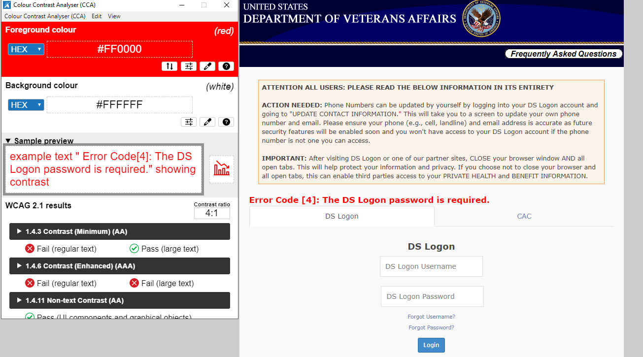

Figure

##### Note 5, Defect 5:

##### The purpose of links cannot be determined from link text alone or from context. The following are examples:

* Example 1. The purpose of the link text “this Form” cannot be understood, from the link text alone or from context. It occurs on contact us link page. Work Path: My HealtheVet Home -> on Login page-> Press on Contact us link -> link text “this Form.” (**New: 08/31/2022).**
* Example 2. The purpose of the link text “here link” cannot be understood, from the link text alone or from context. It occurs on Rules of use page. Work Path: My HealtheVet Home-> Go to Login page-> press Login.gov link-> on Rules of use page “here link.” Check all instances of same issue. (**New: 08/31/2022).**

##### Note 6, Defect 6:

Headings and labels do not describe the topics or purpose of the content to which they belong. The following are examples:

* Example 1. Labels are not described the topics or purpose of the for the “Date edit field” to which they belong. It occurs on Account Activity History page. Work Path: My HealtheVet Home page-> Select [Personal Information](https://www.myhealth.va.gov/mhv-portal-web/personal-information) menu-> Select My account sub-menu - > press on Account Activity History link-> “From” and “to” Edit fields; i.e., during navigation with tab key on keyboard the screen reader announces “From edit field” instead of “From Date edit field.” (**New: 08/31/2022**).
* Example 2. Labels are not described the topics or purpose of the “Phone Number extension edit field” to which they belong. It occurs on Add Treatment Location Information page. Work Path: My HealtheVet Home page-> select [Get Care](https://www.myhealth.va.gov/mhv-portal-web/get-care) menu->Select Treatment Facilities sub-menu link-> Press on Add New button: on Add Treatment Location Information page; i.e., during navigation with tab key on keyboard the screen reader announces “Ext edit field” instead of “Phone Number Extension edit field.” See figure 4 below. Check all instances of same issue. (**New: 08/31/2022**).

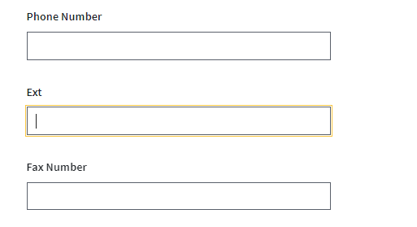

**Figure 4**

**Note 7, Defect 7:**

Keyboard operable user interface elements do not have a visible indication of focus. The following is an example:

* The Ascending/Descending button on VA appointment summary table header do not have a visible indication of focus. Work path: [My HealtheVet](https://www.myhealth.va.gov/mhv-portal-web/web/myhealthevet) Home-> Select Get Care menu -> Select Care Givers link- > Press on Appointments link-> on Appointment summary table column header:- Ascending/descending button has no visible indication on focus. See figure 5 below. Check all instances of same issue. (**New: 08/31/2022).**

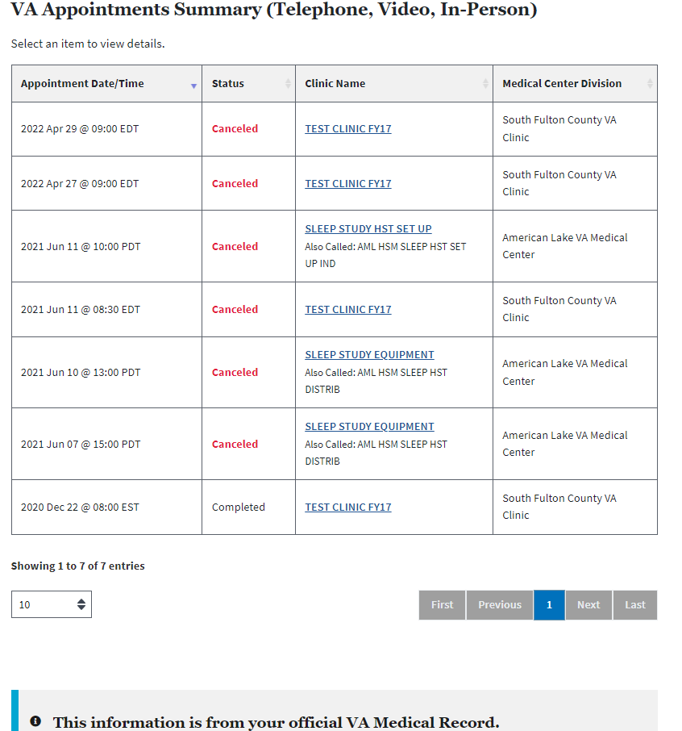

Figure

**Note 8, Defect 8:**

Labels and instructions are not provided when content requires user input. The following are examples:

### Example 1. No visual label (*/required) is provided for the “Enter you email address required” edit field, i.e., during navigation with tab key on keyboard, the user of screen reader hears “Enter you email address required edit.” Work path: My HealtheVet Home-> Select Login page-> Press Login.gov link-> Create your account page. See figure 6 below. Check all instances of same issue. (New: 08/31/2022).

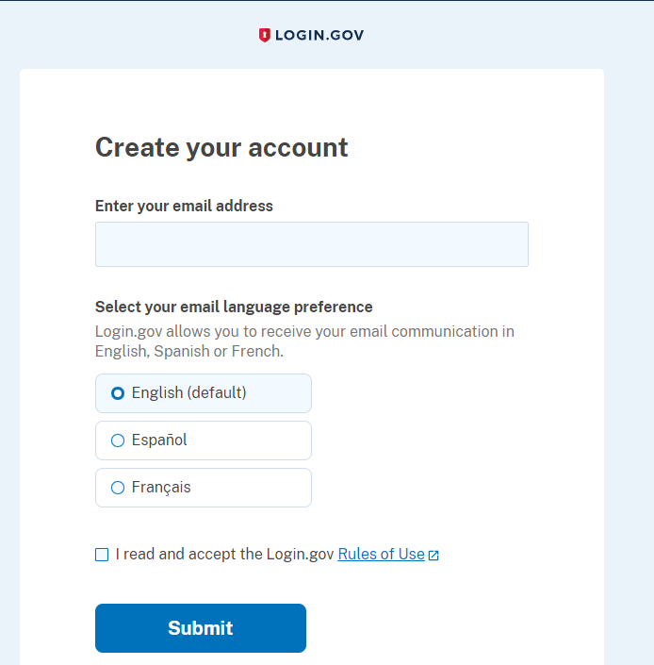

Figure

### Example 2. No visual label (*/required) is provided for the “My HealtheVet User Id & Password required” edit fields: i.e., during navigation with tab key on keyboard, the user of screen reader hears “My HealtheVet User Id required edit.” Work path: My HealtheVet Home-> Select Login page Option 2: Continue to My HealtheVet only. Check all instances of same issue. (New: 08/31/2022).

### Example 3. Labels and instructions are not provided for the Map Zoom in/Zoom out symbols(+/-). Work path: My HealtheVet Home-> Appointment->Find VA Location-> VA Location Map. Check all instances of same issue. (New: 08/31/2022).

##### Note 9, Defect 9:

Content is not properly encoded and causes assistive technology to convey incorrect information. The following is an example:

### Interactive elements are not encoded properly and causes assistive technology conveyed duplicate elements presentation(announced). This behavior is present in My HealtheVet Home page; i.e., during navigation with tab key on keyboard the interactive element “Premium link” is announced twice by the screen reader. Check all instances of same issue. (New: 08/31/2022).

##### Note 10, Defect 10:

The name, role, state or value of user interface elements in the product cannot be understood (programmatically determined). The following are examples:

* Example 1. The role of the required field label “*/required ” in this product cannot be understood by the user of Assistive Technology. It occurs on Find VA Location page Facility Type Combo box * required field, i.e., during navigation with tab key on keyboard, the user of screen reader does not hear “Facility Type Combo box * required field.” Work Path: My HealtheVet Home-> Select Appointment link-> Press on VA Facility Locator link->on Find VA Location page: - Facility Type Combo box* required field. Check all instances of same issue. (**New: 08/31/2022**).
* Example 2. The Name of the Combo box label “Facility Type” in this product cannot be understood by the user of Assistive Technology. It occurs on Find VA Location page Facility Type Combo box * required field, i.e., during navigation with tab key on keyboard, the user of screen reader does not hear “Facility Type Combo box.” Work Path: My HealtheVet Home-> Select Appointment link-> Press on VA Facility Locator link->on Find VA Location page: - Facility Type Combo box* required field. Check all instances of same issue. (**New: 08/31/2022**).
* Example 3. The change of notification in this product is not provided to the user of Assistive Technology. It occurs on [My HealtheVet](https://www.myhealth.va.gov/mhv-portal-web/web/myhealthevet) home page when the user press on “Talk to the Veterans Crisis Line now Button.” The Modal window with the title/text “We’re here anytime day or night – 24/7” is popped up. While the modal window “We’re here anytime day or night – 24/7” is active, the other content in the application is dimmed and inactive. The title/text of this modal window is not announced by the Assistive technology. See figure 7 below. (**New: 08/31/2022**).

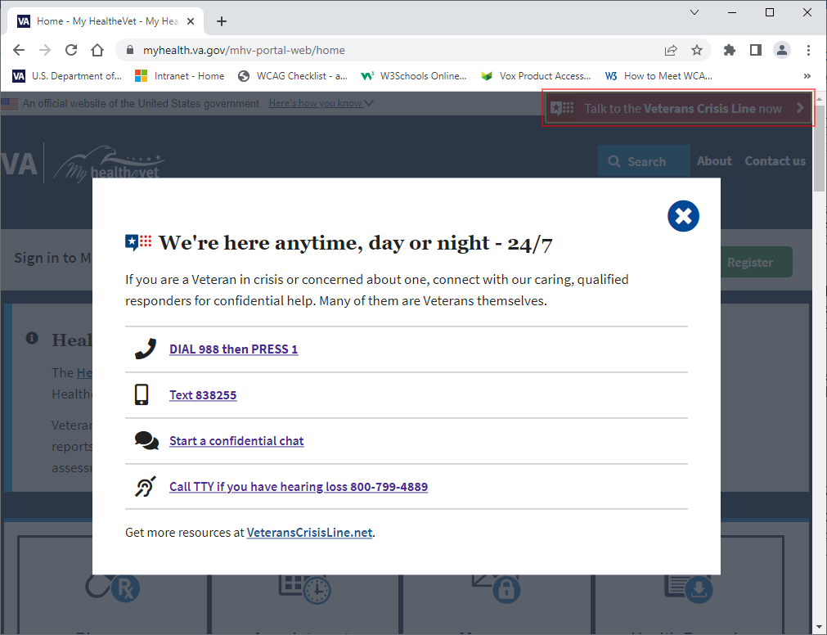

Figure

* Example 4. The State of the Check box group in this product cannot be understood by the user of Assistive Technology. It occurs on Register page. Work Path: My HealtheVet Home-> Login page-> Press on Register link, i.e., during navigation with tab key on keyboard, the user of screen reader does not hear “Check all that apply*.” Check all instances of same issue. (**New: 08/31/2022**).

#### Example 5. The State of the Radio button group in this product cannot be understood by the user of Assistive Technology. It occurs on Check your online health records page. Work Path: My HealtheVet Home-> Press Contact us link->Press on What is VA blue button? link: on Check your online health records page, i.e., during navigation with tab key on keyboard, the user of screen reader does not hear “Which Blue Button feature surprised you the most?” Check all instances of same issue. (New: 08/31/2022).

#### Example 6. The value of the Edit fields (mg/dl) in this product cannot be understood by the user of Assistive Technology. It occurs on Check your online health records page. Work Path: [My HealtheVet](https://www.myhealth.va.gov/mhv-portal-web/web/myhealthevet)->Select [Track Health](https://www.myhealth.va.gov/mhv-portal-web/track-health) menu->Select [Vitals](https://www.myhealth.va.gov/mhv-portal-web/vitals) link-> on Cholesterol (Lipids Profile)page; i.e., during navigation with tab key on keyboard, the user of screen reader hears “Total Cholesterol* Edit” instead of “Total Cholesterol* mg/dl Edit.” See figure 8 below. Check all instances of same issue. (New: 08/31/2022).

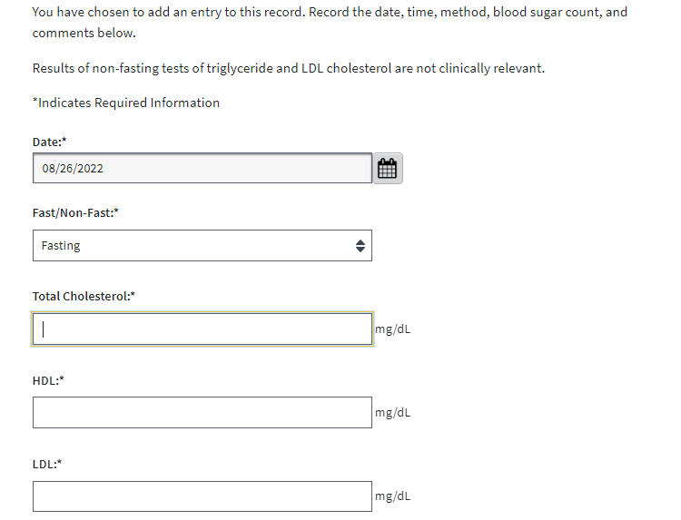

Figure

##### Note 11, Defect 11:

A visual mode that enables users to make use of limited vision is not provided. The following is an example:

* During navigation with tab key on keyboard the “Opt Out” button text color changes. When the text color changes it is difficult to read the text for limited vision user. It occurs on Electronic Record Sharing Options page. Work Path: [My HealtheVet](https://www.myhealth.va.gov/mhv-portal-web/web/myhealthevet) home->select [Personal Information](https://www.myhealth.va.gov/mhv-portal-web/personal-information) menu-> Select Download My Data sub-menu- > Press on Electronic Record Sharing Options -> Opt Out button. See figure 9 below. Check all instances of same issue. (**New: 08/31/2022**).

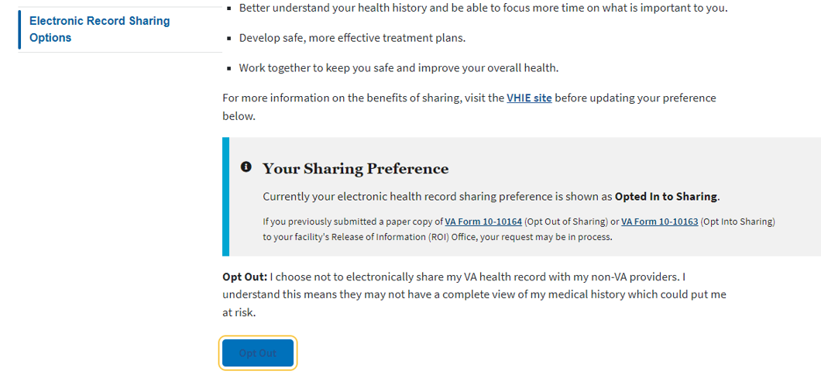

Figure